Attach Contractor/ Vendor’s Business Card Here

550 Meeting Street, Charleston, SC 29403
Company Name: _________________________________________________________________
Contact Name: __________________________________________________________________
Contact Title: __________________________________________________________________
Email: ________________________________________________________________________
Cell Phone: _________________________ Office Phone: _________________________________
Website: __________________________________________________________________________
Address: __________________________________________________________________________
City: _________________________ State: _________________ Zip Code: ______________
Year Established: ____________ Number of Employees: ____________

Contractor/Vendor Registration form

Classification:
- Section 3 Business
- Woman Owned Business Enterprise
- Minority Owned Business Enterprise
- Qualified Disabled Veteran Owned
- Small Business Enterprise
- None of the Above
Product or Service Summary and Code:
_________________________________________________________________________________________________________________________________________________________________________________________________________________________________________________________
By completing this form, I give The Housing Authority of the City of Charleston (CHA) permission to send invitations for bids, quotes, etc. to my business and to add my information to the CHA Contractor/Vendor Registry.

Signature: ___________________________ Date:__________________
Scan to access
The Procurement & Contracts
Management Department’s Solicitation Information
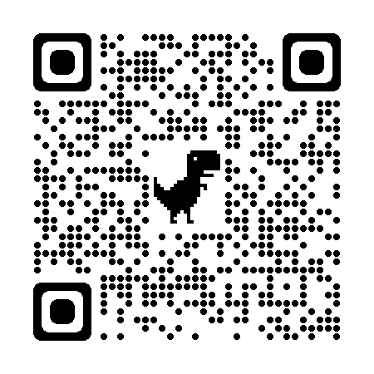

Form Revised 03/18/2022

